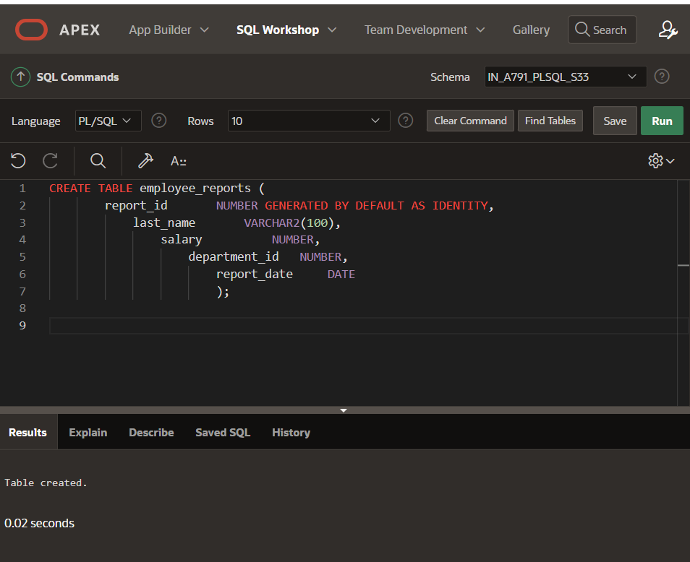

CREATE TABLE employee_reports (

report_id NUMBER GENERATED BY DEFAULT AS IDENTITY,

last_name VARCHAR2(100),

salary NUMBER,

department_id NUMBER,

report_date DATE

);

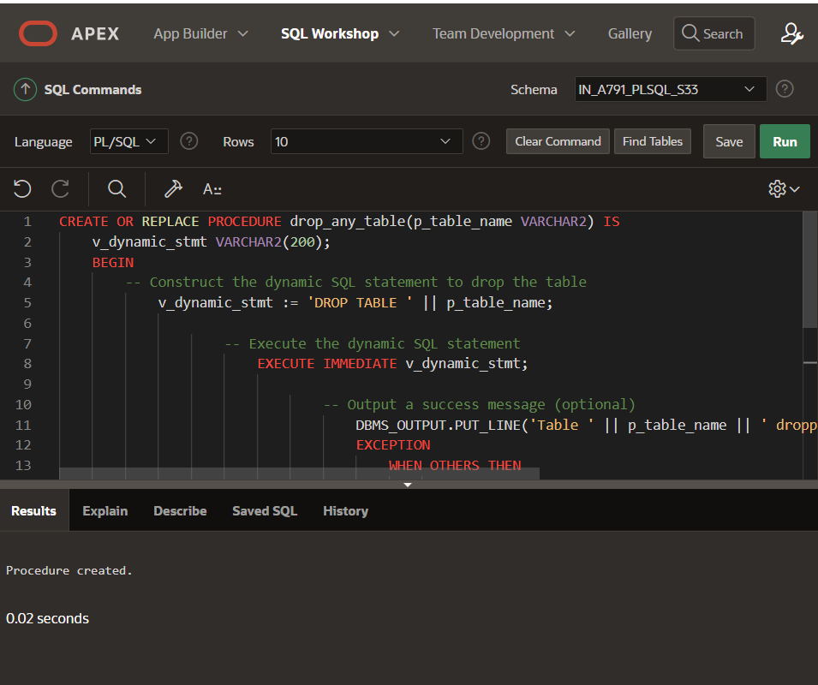

CREATE OR REPLACE PROCEDURE drop_any_table(p_table_name VARCHAR2) IS

v_dynamic_stmt VARCHAR2(200);

BEGIN

-- Construct the dynamic SQL statement to drop the table

v_dynamic_stmt := 'DROP TABLE ' || p_table_name;

-- Execute the dynamic SQL statement

EXECUTE IMMEDIATE v_dynamic_stmt;

-- Output a success message (optional)

DBMS_OUTPUT.PUT_LINE('Table ' || p_table_name || ' dropped successfully.');

EXCEPTION

WHEN OTHERS THEN

-- Handle any exceptions that may occur

DBMS_OUTPUT.PUT_LINE('Error dropping table ' || p_table_name || ': ' || SQLERRM);

END;

/

